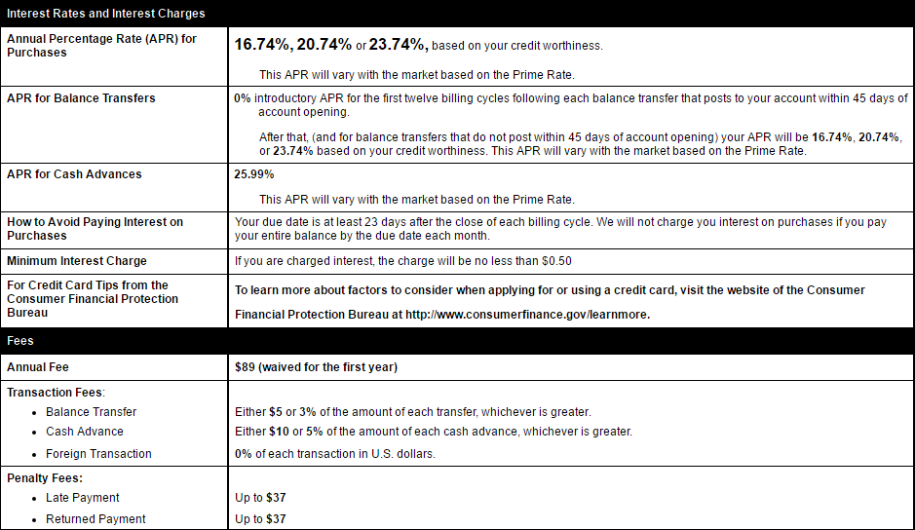
The Empower Platinum Card
- This is a hypothetical example for illustrative purposes.

Definitions:
APR (Annual Percentage Rate) - Annual rate of interest charged to borrowers and paid to investors

Interest - The amount a lender charges for the use of assets expressed as a percentage of the principal

Questions:
- What is the APR for the Empower Platinum Card? _______%

- What is the annual fee for the Empower Platinum Card? Assume you have had the card open for more than a year? $ __________
- You’ve not been very disciplined with executing your Personal Spending Plan (PSP) so you’ve accumulated some revolving debt on an old credit card. You decide to transfer a balance of $250 from an old credit card to the Empower Platinum Card you opened 2 months ago which advertised 0% interest rate for balance transfers.
  - How much will you pay in balance transfer fees? $ __________
  - What interest rate will be applied to the balance transferred? _______%
- You’re traveling to Big Bend National Park and an armadillo suddenly jumps in front of your car. Fortunately, your cat-like reflexes allow you to swerve and miss the cuddly critter, but your right front tire strikes a pothole and causes a flat tire and damage to your rim. It’s going to cost ~$350 to replace. The only auto shop in Marfa, TX only accepts cash, and you left your debit card at the Buccees in Boerne, TX. You decide to use your Empower Platinum Card for a cash advance.
  - How much will you pay in fees for the cash advance? $ __________
  - What interest rate will apply to the cash advance balance? _______%
  - If you carry this cash advance balance for a year, how much interest will you owe? $ __________
- You’re so excited to travel again, your travel planning distracts you from paying your bills. When you finally get around to it, your credit card payment is late. To add insult to injury, you forgot to transfer funds to your monthly obligations account so your payment is rejected due to insufficient funds.
  - How much in penalty fees will you be charged? $ __________

- Your vacation to Bora Bora is finally here. You want to schedule some scuba diving excursions, so you pull out your credit card and charge $600 for three days of diving.
  - How much will you be charged in foreign transaction fees? $ __________

- After your Bora Bora vacation, your credit card balance is $3,000.
  - If you carry this balance over a full year approximately how much interest will you be charged in one year? $ _________ (excluding any penalty fees)
(210) – EMPOWER
4358 Lockhill Selma Rd. | Bldg. 1, Suite 100
Shavano Park, TX. 78249
Securities and advisory services offered through Commonwealth Financial Network, Member FINRA / SIPC, a Registered Investment Advisor. Fixed insurance products and services offered by Empower Wealth Advisors.
Securities and advisory services offered through Commonwealth Financial Network, Member FINRA / SIPC, a Registered Investment Advisor. Fixed insurance products and services offered by Empower Wealth Advisors.

